

PROJECT OVERVIEW
This project will develop a machine learning prototype to analyse West Yorkshire crime data (2018 to 2024). The aim is to identify significant patterns and correlations in criminal activity and build an accurate model that predicts when and where crimes are likely to occur.
This prototype represents an AI-driven solution to support government agencies and citizens in preventing crimes, aligning with the responsibilities of an Associate AI Engineer at Future AI for ALL.

PROJECT GOAL (SMART)
Goal: Develop a functional and accurate AI prototype that predicts crime likelihood with 80%
+ accuracy, by the final deadline of April 3, 2026.

SMART  Element | Description
Specific | Build a machine learning model using data mining and decision-making methods to analyse the West Yorkshire crime dataset and predict  potential crime locations and times.
Measurable | Success will be measured by its predictive accuracy, which will be tested and evaluated. Project success is also measured by achieving a 60%+ accuracy.
Attainable | Achievable using open-source dataset and standard AI development  tools.
Relevant | Directly applies AI methods to a real-world social issue, fulfilling module  outcomes.
Time-bound | The final group prototype and all supporting files must be submitted by  April 3, 2026, with a live demo on April 6, 2026.

Business Case & Benefits

Business Case:
The West Yorkshire crime dataset is vast, with over 1 million records and 12 fields, but includes inconsistencies such as missing or poorly documented entries. Traditional analysis fails to uncover actionable insights.

This project will use data mining and machine learning to process and interpret this data, producing a predictive model that identifies crime hotspots and common trends.

Benefits:
- Discovery of new insights into crime trends in West Yorkshire.
- Identification of hidden patterns using decision trees and correlation analysis.
- Development of visual crime heatmaps showing hotspots.
- Improved understanding of relationships between crime type, location, and outcomes.

Scope

In-Scope:
- Cleaning and processing the West Yorkshire dataset (2018-Jan 2024).
- Analysis of relationships between crime type, location, month, and outcome.
- Development of data visualizations (heatmaps, trend graphs).
- Building a prototype AI solution using data mining and decision trees.
- Documentation (PID, agile sprints, GitHub versioning).

Out-of-Scope:
- Analysis of any data outside the specified 2018-Jan 2024 West Yorkshire dataset.
- Development of a fully deployed, production-grade, or live-streaming application (the deliverable is a prototype).
- Collection of new primary data.

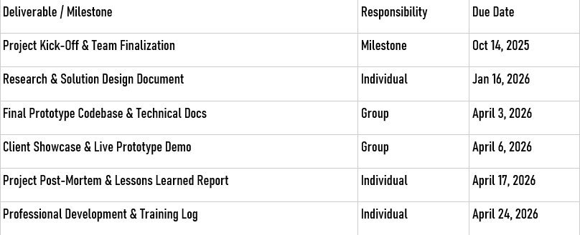
Key Deliverables & Milestones

Project Cost Estimation (Budget)
- Labour Cost Calculation (Three-Point Estimate)
This calculation is based on a 3-person team, with each person working 3 days/week (0.6 FTE) over the 9-month project, using an example intern salary of £30,000/year.
- Likely Cost (L): £40,500

- Estimated Labour Cost (Average): £44,550
Result: £44,550

Cost Item | Category | Estimate | Total Cost
Project Labour | Direct (Variable) | (£32.4k + £40.5k + £60.75k) / 3 | £44,550
Cloud Services | Direct (Fixed) | £10/month for 9 months | £90
Software Licenses | Direct (Fixed) | Provided by FALL | £0
FINAL BUDGET |  |  | £44,640

Project Team & Stakeholders
- Project Team (Associate AI Engineers):
[Alaedine Ait Bella] (Role: Associate AI Engineer / 1st ScrumMaster) [Reyad taha] (Role: Associate AI Engineer / Team Member)
[Pana Sharif] (Role: Associate AI Engineer / Team Member)

Key Stakeholders:
Internal Sponsor: [ Dr. Kulvinder Panesar] Client: [Client Name – Dr. Irfan Mehmood] Project Lead: [Alaedine Ait Bella]

Constraints & Assumptions

Constraints:
- All project deadlines are fixed.
- The project must follow FALL's agile project management framework and use required tools (GitHub, MS Project).
- The dataset is limited to 1,048,575 rows from 2018-Jan 2024.
- The Context column is 100% null and unusable.

Assumptions:
- Cleaned open-source data is reliable and enough for 60%+ model accuracy.
- Client and Project Lead are available for regular feedback.

- Access to required development tools (Python, Google colab, GitHub)

Project Risks
- Data Quality Risk: The dataset has significant data quality issues that could jeopardize the 80% accuracy goal. Specifically:
The Crime ID and Last outcome category columns are missing ~15% of their data.
Last outcome category data is problematic, with "Missing Outcome" being the third-largest category.
There is "inconsistent documentation" for locations, with "No Location" being the second-most common entry for crime locations in each month.
- Ethical Risk: The model may inherit historical biases, leading to a non-responsible AI product. For example, "Violence and sexual offences" are the most dominant crime type, and its primary outcome is "Unable to prosecute suspect". Relying on this data could skew the model.
- Resource Risk: As this is an intern-led project, there is a risk of project delays if team members fail to coordinate or manage tasks effectively.
- Scope Creep Risk: The client may request features or analysis beyond the agreed-upon prototype scope during feedback sessions.

Success Criteria
This section defines the specific, measurable criteria that will determine if the project is a success. Success will be measured in two key areas: Project Outcomes and Business Objectives.

Project Outcomes (Measurable Metrics)
    - Primary Metric: The main project goal is to "Determine an accurate model to predict where crimes are likely to be, and when they are likely to occur". Success is achieved by developing a functional AI prototype that demonstrates a predictive accuracy of 80% or higher.

Secondary Metrics:
      - Successful creation of data visualizations, specifically a "crime heat-map," to identify crime hotspots.
      - Successful identification of new patterns and correlations between crime types, locations, and outcomes.

Business Objectives

    - Client Value: The prototype and its findings must provide "new insights" into the West Yorkshire crime data, as outlined in the business case.
    - Completion: All key project deliverables (from Section 5) must be completed and delivered to the client and internal sponsor by the final deadline of April 6, 2026.

OKRs (Objectives and Key Results)
Objective: Develop a functional AI prototype to predict crime likelihood in West Yorkshire.

Key Results:
  - Achieve a predictive accuracy of 80% or higher on the test dataset.
  - Deliver visualizations (crime heatmaps) successfully identifying crime hotspots.
  - Identify and report on new patterns/correlations between crime type, location, and outcome.
  - All deliverables submitted by April 3, 2026, and demo completed by April 6, 2026.

Approvals
The undersigned parties agree to this project charter and authorize the project to commence. Client: ( )
  - Signature:
  - Date:
Project Lead: ([Faculty Supervisor Name])
  - Signature:
  - Date:

